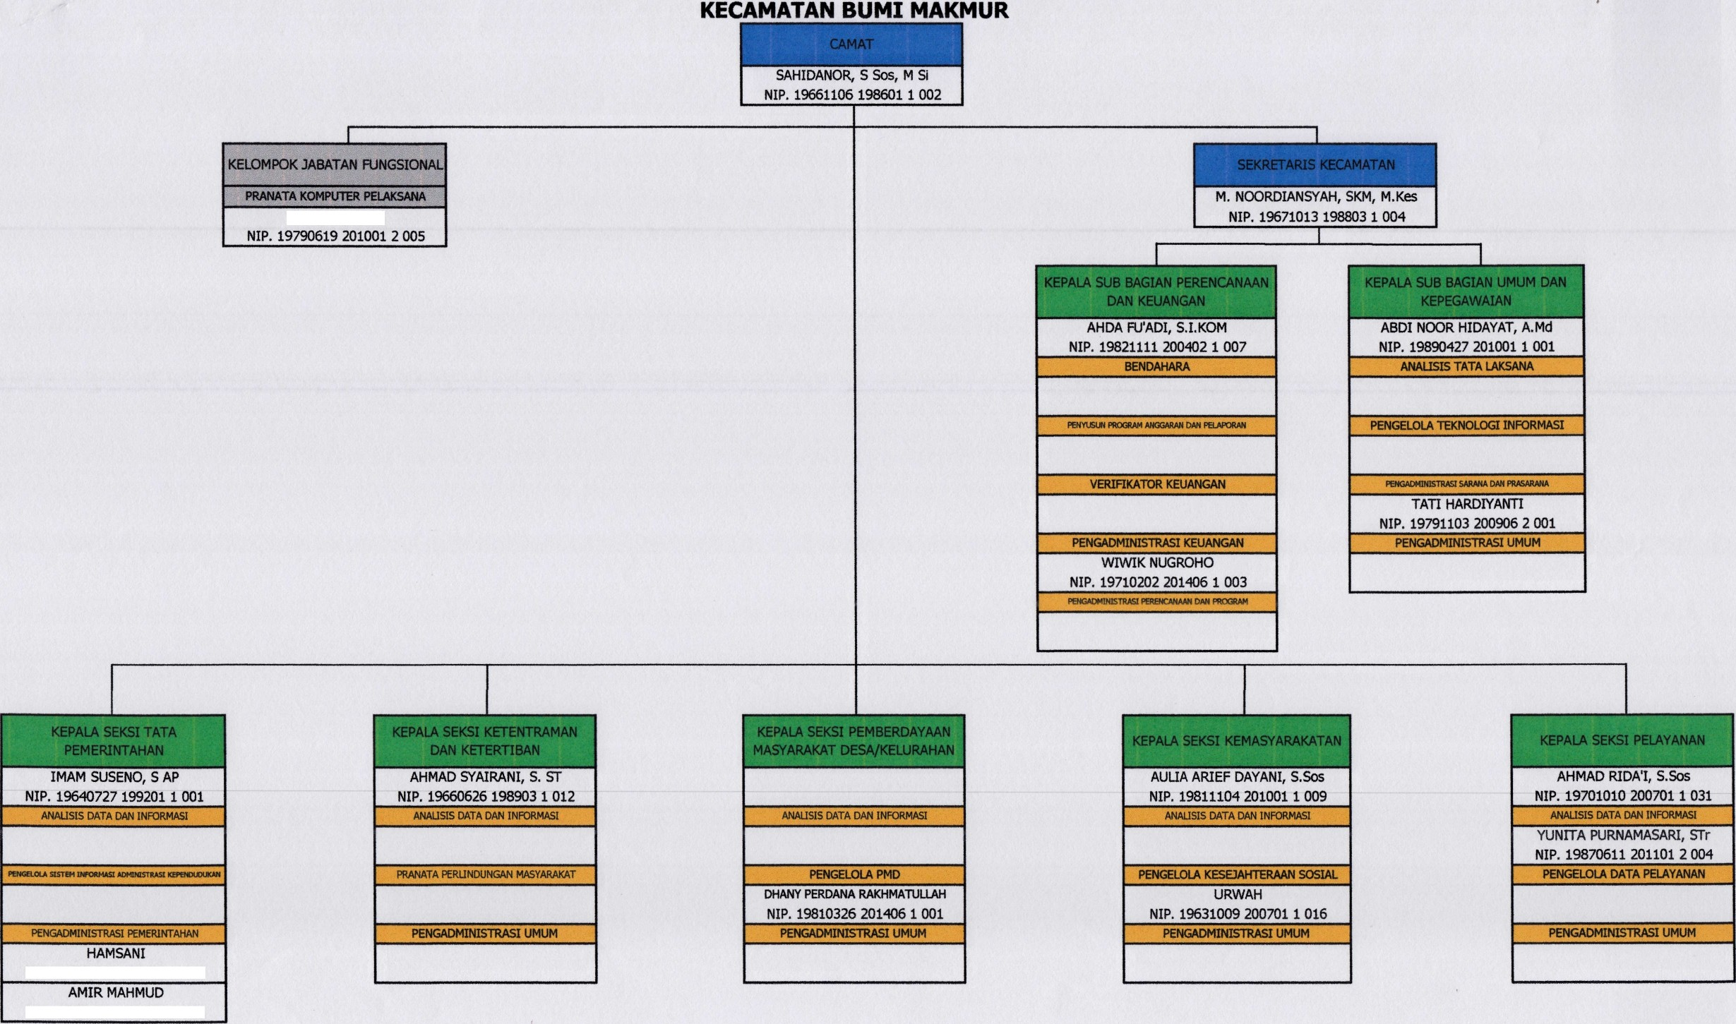
BAGAN STRUKTUR ORGANISASI DAN TATA KERIA

Drs. NASRULLAH
NIP. 19650103 199103 1 009
TUKIAH, A. Md
NIP. 19790619 201001 2 005

MUTTABA, S. Pd
NIP. 19660903 201001 1 001
MULYADI, S.Kep. MM
NIP. 19770101 199603 1 005

MUHAMMAD FAESAL YASSIN, A. Md
NIP. 19860614 201502 1 002

NOORFIAT
NIP. 19680129 198903 1 003
LAILI MUZAKIR
NIP. 19821003 200501 1 005

RINI AMBARWATI, ST
NIP. 19800215 201503 2 001
H. AHMAD RIDA’I, S. Sos
NIP. 19701010 200701 1 031
FATIMAH, S. ST, M.M
NIP. 19690910 199003 2 007

MUHAMMAD GALIH SAPUTRA, ST
NIP. 19911020 201402 1 001

WAHYUDIANNOOR, A. Md
NIP. 19930521 202012 1 013

YUSUP, S.Pd
NIP. 19710417 200604 1 005
HAMSANI
NIP. 19790820 200701 1 010

PEGAWAI TIDAK TETAP ( PTT ) :

- AINUN JARIAH, SE 3. SYARIF HIDAYAT, A. Md 5. REHLAH 7. ISWANDI SYUKUR
- JAMILAH, S. Kom 4. AKHMAD MUSTAFA 6. SYAHRUDIN

